Insert Your Church Name Here
Date

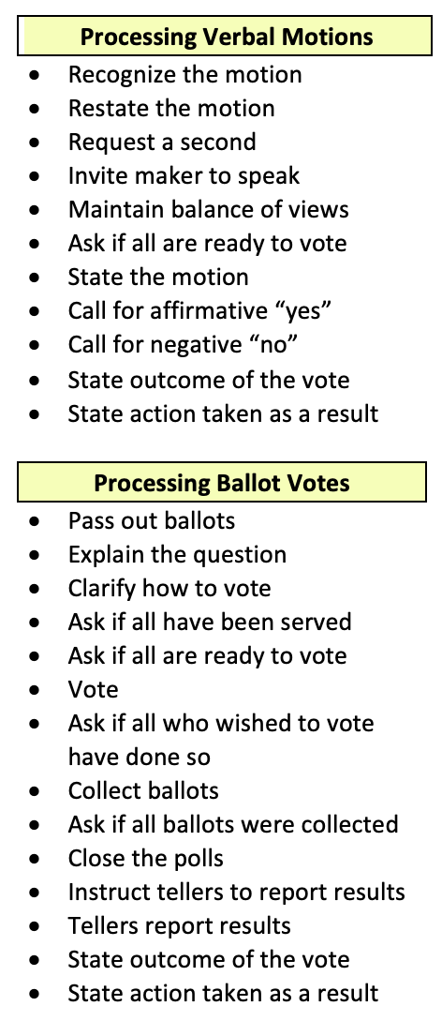
I. CALL TO ORDER Acting Chair

Welcome. My name is insert your name here, and I am the acting Chair of the Board during our search for a new pastor. I would like to call the special business meeting of insert your church name here to order. The stated purpose of our meeting today is threefold:
- To give a report of the pastoral search committee tasked with the screening and identification of the most qualified and available candidate to fill the office of lead pastor.
- To vote on a pastoral candidate presented by the Search Committee and to conduct business competently and in a spirit of unity.
- To build faith as we work together to build God’s Kingdom in our community.

II. PRAYER AND SCRIPTURE READING Acting Chair

Our first order of business is the reading of Scripture and prayer for God’s blessing and guidance upon our meeting.

⁵If any of you lacks wisdom, you should ask God, who gives generously to all without finding fault, and it will be given to you. ⁶But when you ask, you must believe and not doubt, because the one who doubts is like a wave of the sea, blown and tossed by the wind. ⁷That person should not expect to receive anything from the Lord. ⁸Such a person is double-minded and unstable in all they do (James 1:5-8 NIV).

Let us pray and seek God’s blessing together.

III. OPENING COMMENTS Acting Chair

Chair’s Suggested Guidelines. I want to state a few guidelines we should follow if we are going to have a good business meeting.
- Attitude: To me, our attitude during this meeting is more important than the business we discuss.
- Discussion: The call to meeting (meeting notification) is what determines what topics can be addressed today. I want you to feel free to ask any questions specifically related to this election and voice your opinion; but as a Spirit-filled believer, we must remember that it is incumbent upon us to maintain a spirit of love and cooperation.
- Robert’s Rules of Order: As acting chair, I will respect your opinion, but please remember that it is your opinion. It is no better or no worse than someone else’s. We may not be sure your opinion is right, but we can certainly be sure if your attitude is right. That is why I will be following parliamentary procedure informally so we can be assured that everything will be done decently and in order.

At this time, I am going to ask for our first roster report.

V. ROSTER REPORT Roster Person

Give the first roster report to establish that you have met your bylaw requirement for a quorum.

According to our bylaws:

Insert the text concerning quorum required by your bylaws and the official reference here: BYLAWS, Article ?, Section ?.

Voting members
Nonvoting visitors
Total

V. SEARCH COMMITTEE REPORT Acting Chair

On behalf of the Search Committee, I would like to make a formal recommendation to the membership for our new lead pastor.
- We completed the 13 steps of our network’s plan entitled RISE UP to help identify the most qualified, available, and willing candidate to lead our church.
- Present the recommended candidate: Insert full name of candidate here.

VI. ROSTER REPORT (before elections) Roster Chair

Give the second roster report prior to casting the ballot—even if it is the same as before.

According to our bylaws:

Insert the text concerning quorum required by your bylaws and the official reference here: BYLAWS, Article ?, Section ?.

Voting members
Nonvoting visitors
Total

VII. ELECTIONS Acting Chair

- Reading of qualifications from bylaws. Read the portion of your bylaws that give the qualifications and duties of the lead pastor and quote the article and section associated with them.
- Vote needed: Read the kind of vote (majority or 2/3) required to elect a pastor and the bylaw article and section they are from.
- Term elected: Note whether the pastor is elected to a specific or indefinite term and the bylaw article and section the information is from.

- Nomination report from Search Committee. Once again, mention the full first and last name of the candidate.

- Voting instructions and vote distinction are in the affirmative to elect the committee’s nominee.
- “Yes” is a vote to elect the candidate.
- “No” is a vote to decline the candidate.
- Bylaws require insert again.
- A blank piece of paper will be considered as scrap paper according to Robert’s Rules of Order.
- Are there any questions on how to vote?
- Are you ready to vote?

- Prayer.

- Distribution of ballots.

- Vote.

- Close polls. Once you declare the polls closed, no other ballots may be received.

VIII. TESTIMONIES OF GOD’S GOODNESS Acting Chair

While we are waiting for the tellers to count ballots and bring reports, I thought it would be wonderful if we encouraged each other with testimonies of God’s goodness over the past few months in our lives and church. Who would like to start by sharing an encouraging testimony?

IX. TELLER REPORT Teller Chair

Number of votes cast ________
*Necessary for election ________
Number of “Yes” votes ________
Number of “No” votes ________
Number of illegal votes ________

Result: ________

Having received the necessary votes to execute an election, I declare that insert candidate’s name is, as of this moment, the lead pastor and chair of the board of insert your church’s name here.

X. COMMENTS Acting Chair

IF ELECTED: If elected and present, the candidate and the candidate’s family should come up, accept the church, greet their new congregation, and admonish them.

IF CANDIDATE NEEDS TIME TO PROCESS MARGINAL VOTE: There are times when the candidate receives barely enough votes to be elected. In these cases, the candidate may request additional time to pray about the matter before getting back to the search committee with an answer. If so, the acting chair should say,

“The candidate has requested a few days (be specific) to pray about the matter and the members will be notified of the decision in church the next Sunday.
The scriptures speak to us in situations like this saying, ‘Trust in the Lord with all your heart and lean not on your own understanding; in all your ways submit to him, and he will make your paths straight.” (Proverbs 3:5-6, NIV).”

IF NOT ELECTED, the chair should thank the candidate for taking this journey with them and exploring God’s will and then explain to the church that the search committee will go back to work. This statement may be used,

“Unfortunately, our pastoral candidate has not received the votes required for an election. I would imagine we all feel a sense of vulnerability and disappointment. Although we may not understand how this reality fits into God’s will, we must trust that God is too wise to make a mistake; and the committee will return to the selection process. However, we would like to thank the candidate for helping us identify God’s will. The scriptures speak to us in situations like this saying, ‘Trust in the Lord with all your heart and lean not on your own understanding; in all your ways submit to him, and he will make your paths straight.” (Proverbs 3:5-6, NIV).”

IF CANDIDATE WITHDRAWS AFTER RECEIVING ENOUGH VOTES:

“Unfortunately, after prayer and reflection, (insert candidate’s name) has decided to withdraw (his/her) name from consideration and declined the invitation to be our lead pastor. I would imagine we all feel a sense of vulnerability and disappointment. Although we may not understand how this disappointing reality fits into God’s will, we must trust that God is too wise to make a mistake and return to the selection process. The scriptures speak to us in situations like this saying, ‘Trust in the Lord with all your heart and lean not on your own understanding; in all your ways submit to him, and he will make your paths straight.” (Proverbs 3:5-6, NIV).”

XI. THANKS AND PRAYER Acting Chair

- Appreciation.

I would like to acknowledge a few people whose faithfulness has been used by God to serve this church during this transition. Would you please stand as I call your name: Call the name of each member of the board and/or Search Committee.

- Prayer of thankfulness to God.

XII. ADJOURNMENT Acting Chair

Having concluded our business today, a motion would be in order to adjourn. Is someone willing to make that motion?

COMMON PARLIAMENTARY INQUIRIES

- PARLIAMENTARY AUTHORITY: Why are we governed by Robert’s Rules of Order?

Our Bylaws have prescribed Robert’s Rules of Order as our parliamentary handbook.

Section 1. Parliamentary Authority. In order to expedite the work of the Ministry Network and to avoid confusion in its deliberations, the meetings shall be governed by Robert’s Rules of Order Newly Revised. All rules of government shall be in keeping with the spirit of Christian love and fellowship (RMMN Bylaws, Article XII, Section 1).

﻿When a society or an assembly has adopted a particular parliamentary manual—such as this book—as its authority, the rules contained in that manual are binding upon it in all cases where they are not inconsistent with the bylaws (or constitution) of the body, any of its special rules of order, or any provisions of local, state, or national law applying to the particular type of organization (Robert’s Rules of Order Newly Revised, 12 Edition 2:18, p. 15).

2. ABSENTEE BALLOTS: Why can’t we vote with an absentee ballot?

Procedures for absentee ballots must be outlined in an organization’s bylaws to use them.

﻿Absentee Voting. It is a fundamental principle of parliamentary law that the right to vote is limited to the members of an organization who are actually present at the time the vote is taken in a regular or properly called meeting, although it should be noted that a member need not be present when the question is put. Exceptions to this rule must be expressly stated in the bylaws (Robert’s Rules of Order Newly Revised, 12th Edition 45:56, p. 401).

- SUSPEND BYLAWS: Can we override (suspend) our constitution and bylaws with a vote of the membership in our business meeting?

The bylaws cannot be suspended without the right to do so being prescribed in the bylaws.

The bylaws cannot be suspended (with the exception of clauses that provide for their own suspension under specified conditions (Robert’s Rules of Order Newly Revised, 12th edition 2:8, p. 11).

﻿Rules That Cannot Be Suspended. Rules contained in the bylaws (or constitution) cannot be suspended—no matter how large the vote in favor of doing so or how inconvenient the rule in question may be—unless the particular rule specifically provides for its own suspension (Robert’s Rules of Order Newly Revised, 12th Edition 25:7, p. 248).

- DEFAULT VOTE: What is the default vote needed if the bylaws do not prescribe?

Our parliamentary authority would require us to default to a “majority vote.”

﻿As stated in 1:6, the basic requirement for approval of an action or choice by a deliberative assembly, except where a rule provides otherwise, is a majority vote. The word majority means “more than half”; and when the term majority vote is used without qualification—as in the case of the basic requirement—it means more than half of the votes cast by persons entitled to vote, excluding blanks or abstentions, at a regular or properly called meeting (Robert’s Rules of Order Newly Revised, 12th Edition 44:1, p. 379).

- BLANK BALLOTS: How should blank ballots be tabulated when recording the results of a vote?

Blank ballots should be considered as scrap paper.

﻿Tellers ignore blank ballots and other ballots that indicate no preference, treating them as abstentions (Robert’s Rules of Order Newly Revised, 12th Edition 45:31, p. 394).

